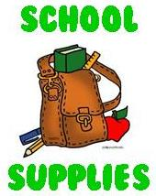

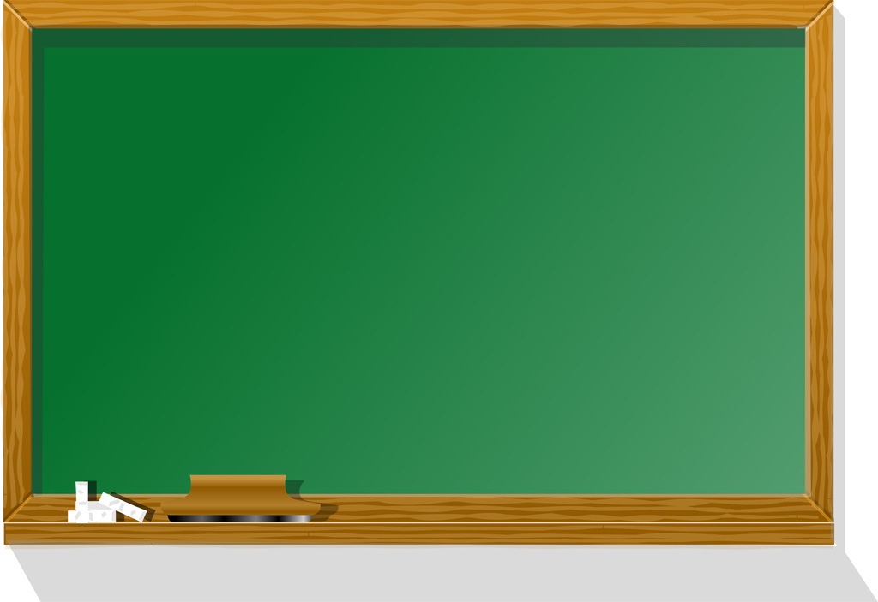

**4- 3 Subject Wide rule Notebooks**

**8- 2-Pocket folders**

**3- Wide-ruled Loose Leaf Paper**

**4- Composition Notebooks**

**1- Box 1 Gallon Ziploc Bags**

**2- Boxes Sandwich size Ziploc Bags**

**4- Boxes of Kleenex**

**2- Pkgs. Kleenex (Pocket Size)**

**2- Rolls of Paper Towels**

**1- Lysol Antibacterial Large Wipes**

**2- Hand Sanitizer (20oz. or more)**

**1- Bottle of Liquid Soap**

**1- Book bag (no wheels)**

**Face Masks (Disposable or Reusable)**

**Headphones**

**\*Please put your child’s name on ALL supplies.**

**\*All Teachers will have supply baskets for students.**

**\*REPLACEMENT of supplies during the year is the student’s responity.**

**1- Zippered Pencil Pouch**

**2- Packs of No. 2 Pencils (24 count)**

**1- Enclosed Pencil Sharpener**

**2- Colored Pencils 12ct**

**2- Packs of Erasable Pens (blue& black)**

**1- Pack of Red Pens**

**3- Highlighters (yellow, orange, green)**

**2- Packs of Pink erasers**

**1- Ruler w/metric markings**

**1- Boxes of Crayola Crayons 24ct.**

**1- Packs of Crayola Markers**

**1- Colored Pencils**

**1- Dry Erase Markers**

**1- Pair of Scissors**

**4- Glue Sticks**

**2- Post-it Notes**